**Capstone Project Summary**

**Dashboard 1 (Job and Shipment trends)**

**Visualization-1**

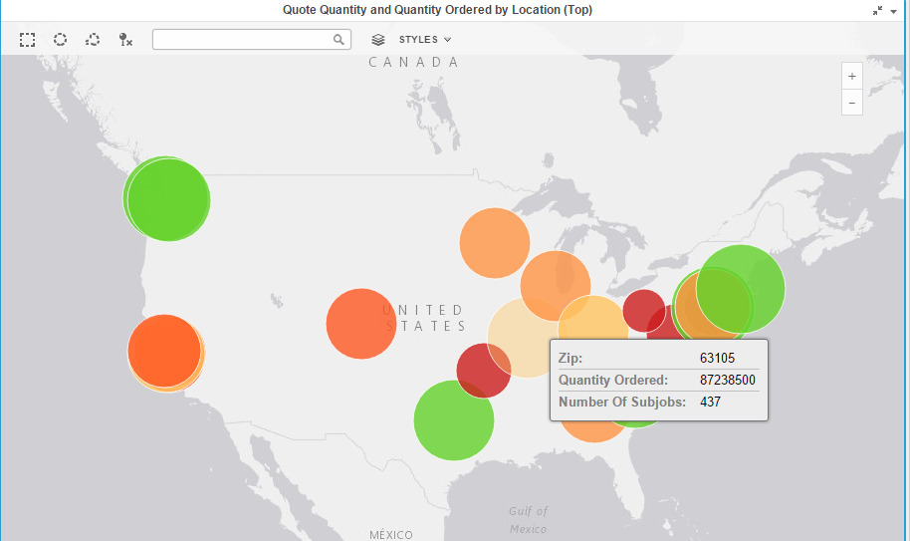

Above visualization provides us information about the locations where quantity ordered is least are marked in red and having most quantity ordered are in green.

The size of bubble shows us the sub job number variation. Bubble with bigger size has most number of subjobs.

The bubble chart on map shows that mostly green are of bigger size with more quantity ordered and more sub jobs eventually.

**Visualization-2**

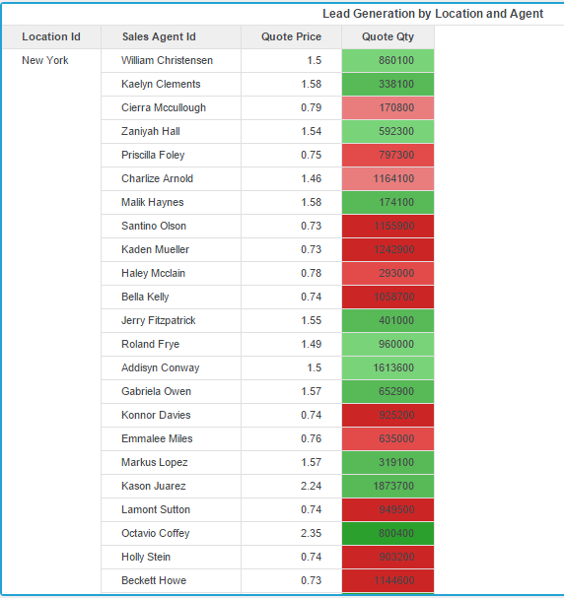

Above visualization shows the different sales agent in different cities with quote price and quote quantity.

For each city, the color by quote quantity value, we can easily identify the agent with least quote value marked in red for each city or Location Id.

Marked in green for each city will be the agent with most quote value.

This helps us do the performance analysis of different sales agent in different locations.

**Visualization-3**

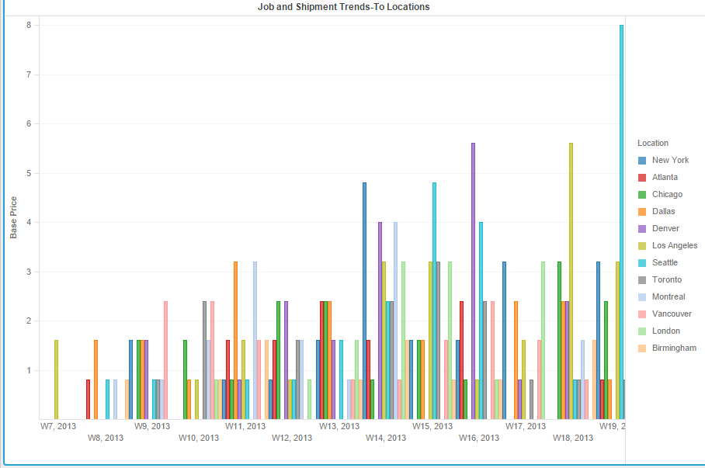

Above visualization shows the change in base price at different locations week wise for date ship by.

Base price values are not available by week for every location.Data is not update per week at each location.

There is no proper trend visible, for some locations base price is increasing as we are moving from 2013 to 2014 and then to 2015 but for some it is fluctuating.

But I can surely say as we move from start of 2013, base prices for most of locations is increasing.After end of 2013,there is some decrease in prices.

**Visualization-4**

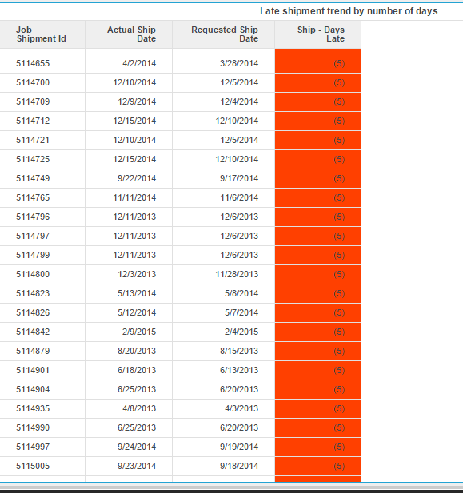

Above visualization shows the delay in days for different shipments by their shipment id.By seing the above we can easily visualize and analyze the shipments which were delayed and why that happened?. We can look into the matter and make a list of most delayed shipments.Orange color here shows the shipment with most number of delayed days.

**Dashboard-1 overall**

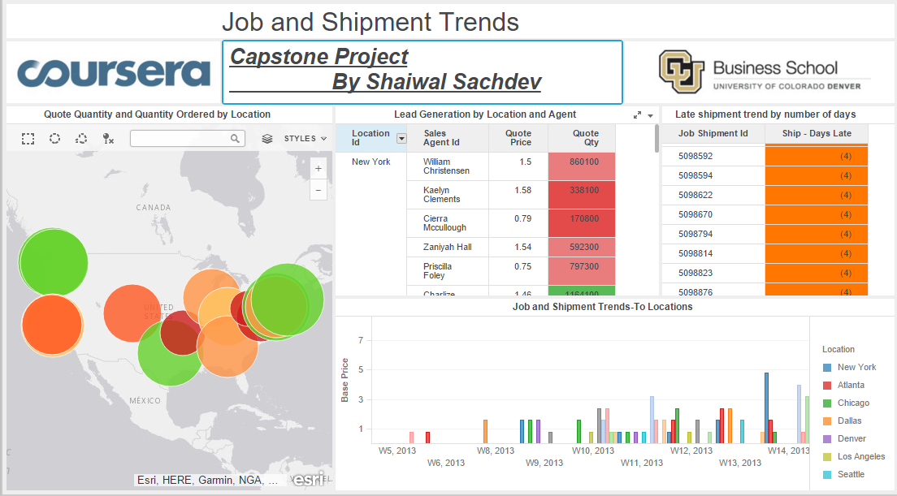

Answers:

* How much revenue does a company generate from its job bookings?

Revenue can be calculated by multiplying the Quote price * Quote quantity. We can easily do that from Lead Generation visualization.

* How many jobs does each sales agent book?

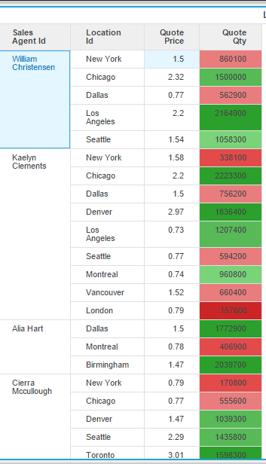

Above visualization can be easily made from Lead Generation by Location and Agent.We can see the different jobs booked by a agent in different locations.It is around 5 to 6 average jobs per agent.

* How many jobs have not yet shipped or have only partially shipped?

This can be easily find out by finding the difference between the current date to the Date Ship by.

Not Yet Shipped== Those whose last ship date is not available.

Partially Shipped= Whose shipments have started and are in the data.

**Dashboard 2 (Job and Shipment trends)**

**Visualization-1**

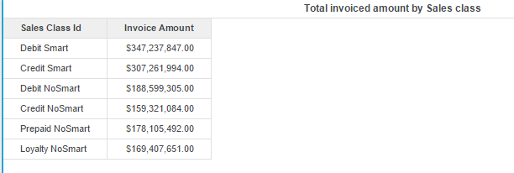Above visualization shows the different invoice amounts for different sales classes.

**Visualization-2**

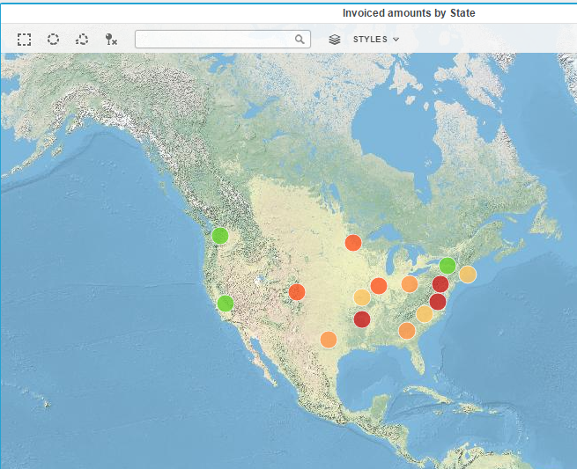

Above visualization shows the different states with invoice amounts shown by color. Marked in green are the states with highest invoice amounts and marked in red should the problem areas.

**Visualization-3**

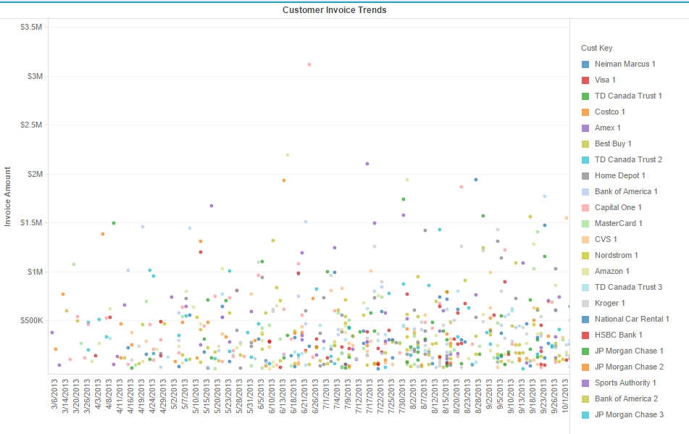

Above visualization shows the change in invoice amount for each customer over a period of time.This can help keep track of amount for each customer by invoice dates.

**Visualization-4**

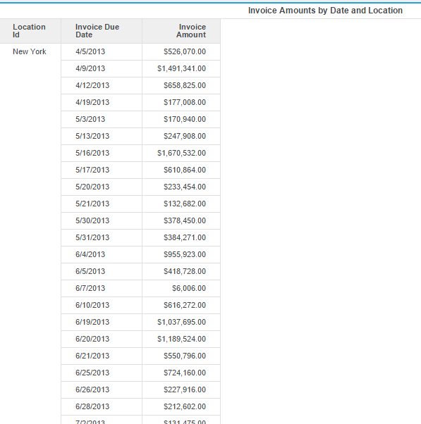

Above visualization shows the different locations with invoice due dates and amount.This can help us visualize the invoice amount about the due dates for different regions.

**Dashboard2-Overall**

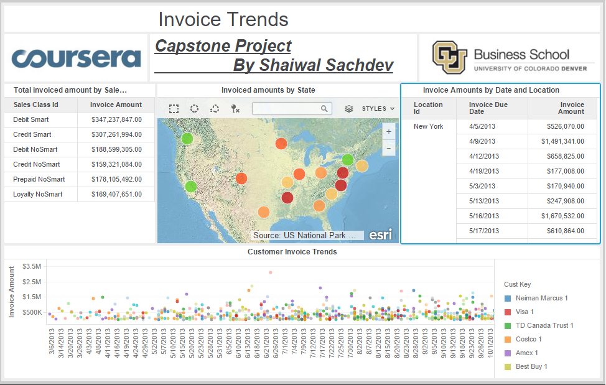

**Answers:**

* Which sales class generate the highest invoice amounts? **Debit Smart**
* How many invoices are generated for a time period?

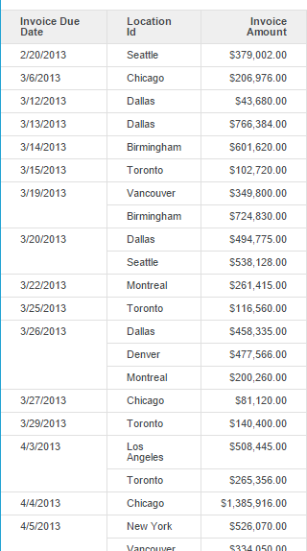

Above visualization can be easily made from grid table showing amounts by location and date.

Now for each date we can see the number of invoices.The date column can be changed to by month, by year to keep track of number of invoice by time.

* What is the total amount invoiced for a time period?

Using the same above visualization for previous question, for each date or time, we can sum up the invoice amounts.

**Dashboard 3 (Financial Performance)**

**Visualization-1**

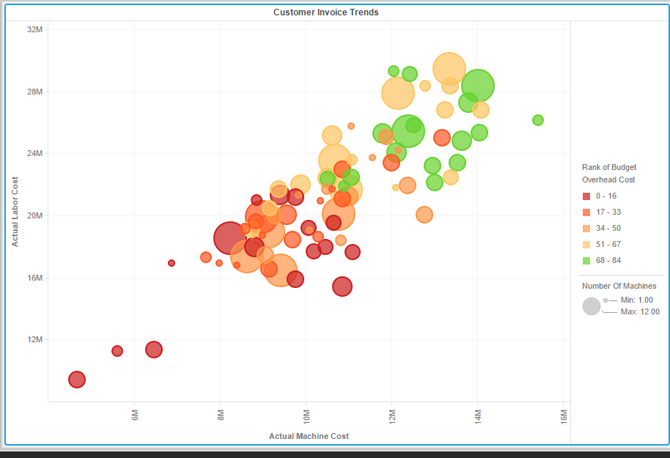

Above visualization shows the analysis of budget overhead cost compared to Labor and Machine Cost.

We can see the bubble in green having most overhead cost and red having lowest overhead cost.

**Visualization-2**

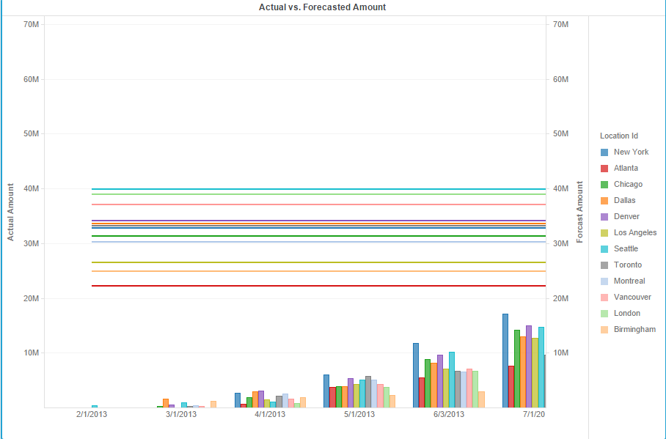

Above visualization shows the comparison for actual vs forecasted amount, for each location.

It also shows the amounts for each location by date.

**Dashboard-3 Overall**

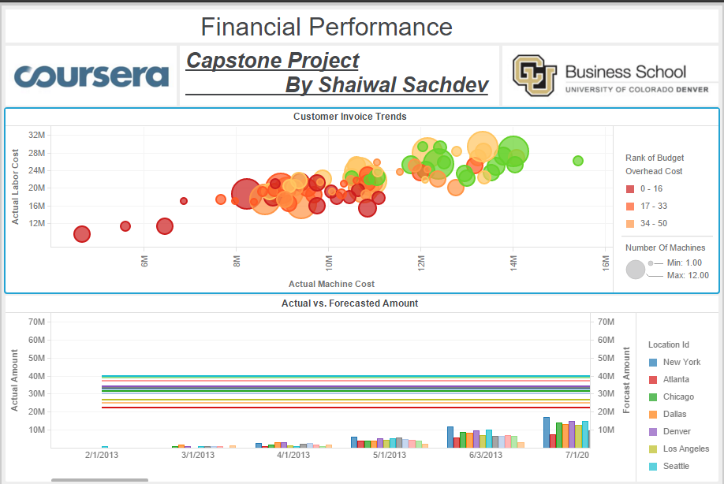

**Answers:**

* Determine the location and the machine which have the highest overall machine and labor cost. Also determine which location has the lowest budget overhead cost.

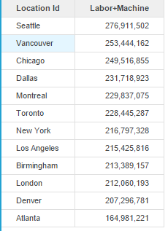

Highest Overall Actual Machine+Labor Cost = Seattle

Lowest Budget Overhead Cost = Atlanta $6838820.8

* Which location is seen to have higher forecast amount in comparison to the actual amount on the basis of time period?

Answer is Vacouver ($655,499,035) difference that is max between forecasted amount and Actual Amount.

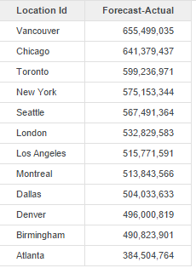

This by making all these visualizations we can find the target regions that are facing problem, keep track of sales agent performance,find the regions which are performing bad,find the region with maximum amount or revenue generated.